iSphere Test Instructions

Inhalt
iSphere Test Instructions 1
Popup Menues 2
Prerequisites 2
IBM i Filter Items Test Instructions 3
Object type *MSGF 3
Object type *DTAARA: 3
Object type *BNDDIR 3
Object type source physical file 3
Object type source physical file member: 4
IBM i Filter Test Instructions 5
Library filter 5
Object filter 5
Member filter 5
iSphere Spooled File Subsystem: 5

Popup Menues

Prerequisites
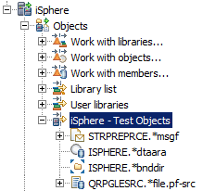
Add an IBM I object filter with the following object types and objects for library iSphere:
- *MSGF
- *DTAARA
- *BNDDIR
- QRPGLESRC

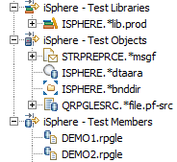
Next add the following three IBM i filters:
- Library filter
- Object filter
- Member filter

IBM i Filter Items Test Instructions
Check the context menu and validate that the following items are available.
Object type *MSGF  iSphere Message File Search  iSphere Message File Editor |  | 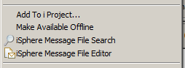
Checked: | RDi | RDP | WDSC
Object type *DTAARA: |  | 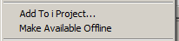  no iSphere entries at all
Checked: | RDi | RDP | WDSC
Object type *BNDDIR  iSphere Binding Directory Editor |  | 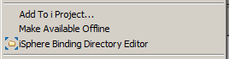
Checked: | RDi | RDP | WDSC
Object type source physical file  iSphere Source File Search |  | 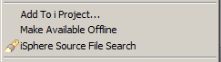
Checked: | RDi | RDP | WDSC
Object type source physical file member:  iSphere Source File Search  iSphere Compare Editor |  | 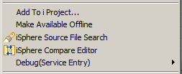
Checked: | RDi | RDP | WDSC
Multiple selected members:  iSphere Source File Search |  | 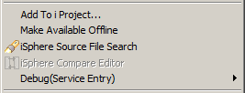
Checked: | RDi | RDP | WDSC

IBM i Filter Test Instructions
In order to check the filter, please click directly on the filter. Do not select one or more objects shown by the filter.
Library filter  iSphere Message File Search  iSphere Source File Search |  | 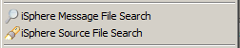
Checked: | RDi | RDP | WDSC
Object filter  iSphere Message File Search  iSphere Source File Search |  | 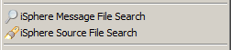
Checked: | RDi | RDP | WDSC
Member filter  iSphere Message File Search  iSphere Source File Search |  | 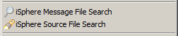
Checked: | RDi | RDP | WDSC
iSphere Spooled File Subsystem:  Spooled File Subsystem |  | 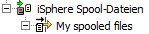  no iSphere entries at all
Checked: | RDi | RDP | WDSC

